**DKTE SOCIETY’S**

**YASHWANTRAO CHAVAN POLYTECHNIC, ICHALKARANJI.**

DEPARTMENT OF

**COMPUTER SCIENCE AND ENGINEERING**

A

Micro Project Report On,

**“Advanced Calculator Using VB.NET”**

Submitted by,

|  |  |  |
| --- | --- | --- |
| Exam seat no | Students Name | Sign |
|  | Aditya Babaso Birangaddi |  |
|  | Atharav Sunil Barkale |  |
|  | Sumit Tanaji Biranje |  |
|  | Vedant Raju Sambare |  |

Under the guidance of

**Prof. Hatgine R. A.**

ACADEMIC YEAR

2020-21

**D.K.T.E. SOCIETY’S**

**YASHWANTRAO CHAVAN POLYTECHNIC, ICHALKARANJI.**

DEPARTMENT OF COMPUTER SCIENCE AND ENGINEERING.

**CERTIFICATE**

This is to certify that,

|  |  |  |
| --- | --- | --- |
| Enrollment No | Students Name | Sign |
| 1915770160 | Aditya Babaso Birangaddi |  |
| 1915770159 | Atharav Sunil Barkale |  |
| 1915770161 | Sumit Tanaji Biranje |  |
| 19157701 | Vedant Raju Sambare |  |

Have successfully completed the micro project entitled,

**“Advanced Calculator Using VB.NET”**

In partial fulfillment of diploma in Computer Science and Engineering at MSBTE, Mumbai.

Date:

Place: Ichalkaranji.

Prof. Hatgine R. A. Prof. Hatgine R. A.

Guide H.O.D

Prof. Kothali. A. P.

Principal

**ABSTRACT**

We have tried to explain about the calculator using VB.NET This program consists of different tools like buttons ,label ,textboxes, and other functions . This program helps user to handle the more records of Calculation. User can add more functions or the arithmetic operations like addition , Substraction ,Division ,multiplication and ETC.

**ACKNOWLEDGEMENT**

An endeavor over long period can be successful only with advice and guidance of many well-wishers. Our sincere thanks to **Prof. Hatgine R. A.** H.O.D. of Computer Science and Engineering, for gives us the opportunity to conduct this micro project.

We would like to thank the Computer Science and Engineering department for assistance and constant source of encouragement. We wish to express our profound and deep sense of gratitude of **Prof. Hatgine R. A.** for spending their valuable time to extend help us in every step of our project.

I would like to thank the staff of Computer Science and Engineering department for their generous guidance.

Last but not the least we would like to thank our classmates and family for their help in every way and constant inspiration in project and for the success of this project and project report.

Thanking you.

Mr. Aditya Babaso Birangaddi

Mr. Atharva Sunil Barkale

Mr. Sumit Tanaji Biranje

Mr. Vendant Raju Sambare

INDEX

|  |  |  |
| --- | --- | --- |
| Sr .No. | Title | Page no. |
| 1 | Introduction | 1 |
| 2 | Program. | 6 |
| 3 | Output. | 10 |
| 4 | Conclusion | 13 |
| 5 | Reference | 14 |

**INTRODUCTION**

Designing the Form

Let's design the form first. What does a calculator need? Well numbers, for one. A display area for the result. A plus sign button, an equals sign button, and a clear the display button.

Here's how our calculator is going to work. We'll have 10 button for the numbers 0 to 9. When a button is clicked its value will be transferred to a display area, which will be a Textbox. Once a number is transferred to the Textbox we can click on the Plus button. Then we need to click back on another number. To get the answer, we'll click on the equals sign. To clear the display, we'll have a Clear button.

If you haven't already, create a new project. Save it as Calculator. To your new form, first add ten Buttons (You can add one, then copy and paste the rest). The Buttons should have the following Properties:

**Name: btn Plus a Number (btnOne, btnTwo, btnThree, etc)**

**Text: A number from 0 to 9. A different one for each button, obviously**

**Font: MS Sans Serif, Bold, 14**

Next, add a Textbox. Set the following properties for the Textbox:

**Textbox  
Name: txtDisplay  
Font: MS Sans Serif, Bold, 14  
Text: Erase the default, Textbox1, and leave it blank**

Three more buttons need to be added

**Plus Button  
Name: btnPlus  
Font: MS Sans Serif, Bold, 14  
Text: +**

**Equals Button  
Name: btnEquals  
Font MS Sans Serif, Bold, 14  
Text: =**

**Clear Button  
Name: btnClear  
Font MS Sans Serif, Bold, 14  
Text: Clear**

**ALGORITHM**

Step 1: Click anywhere on the form

Step 2: In the properties window, under the Text property, type Simple Calculator

Step 3: In the properties window, under the StartPosition property, select CenterScreen

Step 4: In the properties window, under FormBorderStyle, select Fixed3D

Step 5: Click and drag a label from the Toolbox to the form

Step 6: While the label is selected, in the properties window, under the Text property, type Simple Calculator. Note: Since this label is the main text describing the text, you can change the size and boldness of the text under the Font property in the properties window but is not required for this project

Step 7: Proceed to do this for the following labels (5) and place them accordingly. Name them: Operators, Operation, Operand 1, Operand 2, and Result (See picture) Note: Objects can either be dragged or double clicked to be placed onto the GUI

Step 8: Click and drag a button from the Toolbox

Step 9: Place it under the “Operators” label.

Step 10: While the button is selected, in the properties window, under the Name property, enter btnAdd

Step 11: Then under the Text property, enter a + sign

Step 12: Click and drag a TextBox from the ToolBox beside the “Operand 1” label (See picture)

Step 13: While the TextBox is selected, in the properties window, under the Name property, enter txtOperand1

Step 14: Repeat Step 12 but place the second TextBox beside the “Operand 2” label (See picture)

Step 15: Repeat Step 13 but name it txtOperand2

Step 16: Click and drag a label between the two text boxes (See picture)

Step 17: While the label is selected, in the properties window, under the Name property, enter lblOperator

Step 18: Delete the text property of lblOperator so that it is blank

Step 19: Under 9the AutoSize property, select False. Note: This lets you resize the label at your desire

Step 20: Under the BorderStyle property select Fixed3D

Step 21: Click and drag another label beside the “Result” label

Step 22: Repeat Step 17, name it Result

Step 23: Repeat Step 18 and Step 19

Step 24: Click and drag a button from the Toolbox below the “Result” label (See picture)

Step 25: While button is selected, in the properties window, under the Name property, enter btnClear

Step 26: Change the text property for the Clear button to Clear

Step 27: Click and drag a button from the Toolbox beside the Clear button (See picture)

Step 28: While button is selected, in the properties window, under the Name property, enter btnExit

Step 29: Change the text property for the Clear button to Exit

Step 30: Enter the following code by double clicking on each button to open the code window:

**Program:-**

Public Class Form1

Private Sub Button1_Click(sender As Object, e As EventArgs) Handles Button1.Click

TextBox1.Text = TextBox1.Text + "1"

End Sub

Private Sub Button4_Click(sender As Object, e As EventArgs) Handles Button4.Click

TextBox1.Text = TextBox1.Text + "4"

End Sub

Private Sub Button2_Click(sender As Object, e As EventArgs) Handles Button2.Click

TextBox1.Text = TextBox1.Text + "2"

End Sub

Private Sub Button3_Click(sender As Object, e As EventArgs) Handles Button3.Click

TextBox1.Text = TextBox1.Text + "3"

End Sub

Dim FirstValue, SecondValue As Int32

'addition button

Private Sub Button14_Click(sender As Object, e As EventArgs) Handles Button14.Click

TextBox1.Text = TextBox1.Text + "+"

End Sub

'Clear button

Private Sub Button17_Click(sender As Object, e As EventArgs) Handles Button17.Click

TextBox1.Clear()

End Sub

Private Sub Button5_Click(sender As Object, e As EventArgs) Handles Button5.Click

TextBox1.Text = TextBox1.Text + "5"

End Sub

Private Sub Button6_Click(sender As Object, e As EventArgs) Handles Button6.Click

TextBox1.Text = TextBox1.Text + "6"

End Sub

Private Sub Button7_Click(sender As Object, e As EventArgs) Handles Button7.Click

TextBox1.Text = TextBox1.Text + "7"

End Sub

Private Sub Button8_Click(sender As Object, e As EventArgs) Handles Button8.Click

TextBox1.Text = TextBox1.Text + "8"

End Sub

Private Sub Button9_Click(sender As Object, e As EventArgs) Handles Button9.Click

TextBox1.Text = TextBox1.Text + "9"

End Sub

Private Sub Button15_Click(sender As Object, e As EventArgs) Handles Button15.Click

TextBox1.Text = TextBox1.Text + "-"

End Sub

Private Sub Button16_Click(sender As Object, e As EventArgs) Handles Button16.Click

'FirstValue = Convert.ToInt32(TextBox1.Text)

TextBox1.Text = TextBox1.Text + " * "

'TextBox1.Clear()

End Sub

Private Sub Button13_Click(sender As Object, e As EventArgs) Handles Button13.Click

'FirstValue = Convert.ToInt32(TextBox1.Text)

'TextBox1.Clear()

TextBox1.Text = TextBox1.Text + "/"

End Sub

Private Sub Button10_Click(sender As Object, e As EventArgs) Handles Button10.Click

TextBox1.Text = TextBox1.Text + "0"

End Sub

Private Sub SQRT_Click(sender As Object, e As EventArgs) Handles SQRT.Click

Dim num1 As Double

num1 = Val(TextBox1.Text)

TextBox1.Text = Math.Sqrt(num1)

End Sub

Private Sub Button18_Click(sender As Object, e As EventArgs) Handles Button18.Click

If TextBox1.Text < " " Then

TextBox1.Text = Mid(TextBox1.Text, 1, Len(TextBox1.Text) - 1 + 1)

Else

TextBox1.Text = Mid(TextBox1.Text, 1, Len(TextBox1.Text) - 1)

End If

End Sub

Private Sub Button11_Click(sender As Object, e As EventArgs) Handles Button11.Click

TextBox1.Text = TextBox1.Text + "."

End Sub

Private Sub Button19_Click(sender As Object, e As EventArgs) Handles Button19.Click

Dim num1 As Double

num1 = Val(TextBox1.Text)

TextBox1.Text = num1 * num1

End Sub

Private Sub Button20_Click(sender As Object, e As EventArgs) Handles Button20.Click

Dim num1 As Double

num1 = Val(TextBox1.Text)

TextBox1.Text = num1 * num1 * num1

End Sub

'Result

Private Sub Button12_Click(sender As Object, e As EventArgs) Handles Button12.Click

Dim calc As New DataTable()

Dim result = CType(calc.Compute(TextBox1.Text, Nothing), Double)

Dim nextnumber = result

TextBox1.Clear()

TextBox1.Text = TextBox1.Text + result.ToString()

End Sub

End Class

**Output:-**

**1] Addition -:**

­­­­­­

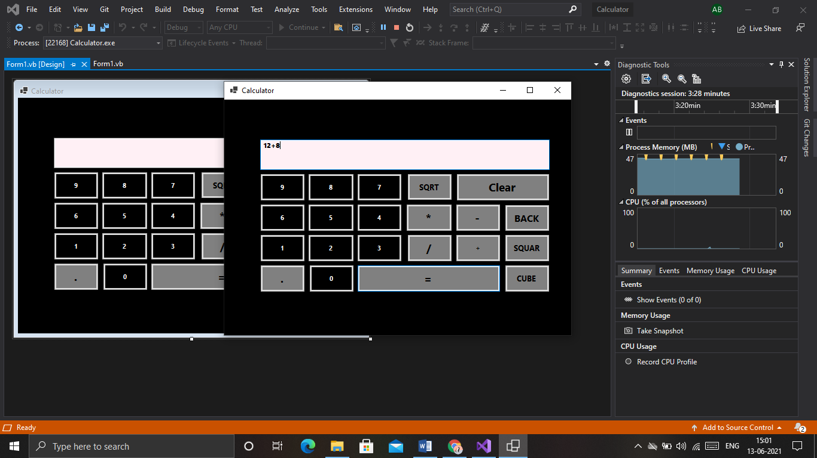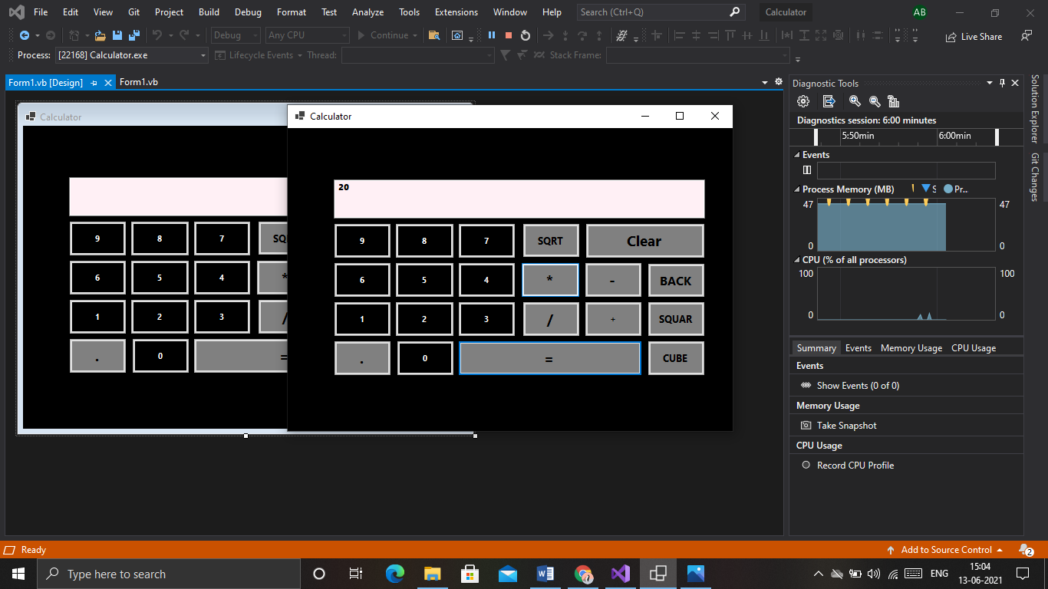

**2] Substraction -:**

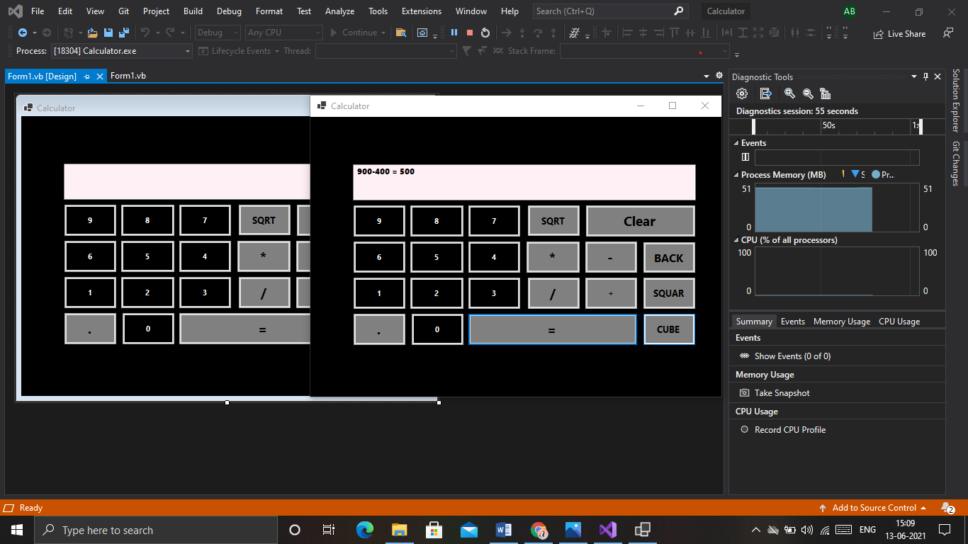

**Conclusion**

The software design project taught us about programming and the documentation involved with creating an engineering project. The limitations of this project were time constraints and limited testing time with the Proteus. The programs could only be tested on the Proteus in class, which made it difficult to debug the code. Our limited experience with creating code for the Proteus also made this project difficult

happy with the outcome of this project and the functioning x o x game we created.

**Reference**

**Websites**

**https ://www.programmingwithbasics.com//2016/03/c-program-forstudent –report-card-src.html.**

**Reference book**

**“object oriented programming in c++” by Balgurusamy**

**“object oriented programming in c++” by lafore**